**Workpaper A.1.B – Ensure That Testing Is Performed To Support Increased Patient Pharmacy Data Volume.**

Source: AuditBoard.

Provided by: Padmalatha Ajit (Senior Manager, Application Development)

Date: 5/20/2021

Description: The attached screenshot below shows the SimpleDose Application Batch Server Sizing (List 3). The report includes a testing of total estimated additional disk space value carried out by the application team prior to Phase 1 release of SimpleDose Application to ensure that the storage capacity to support Patient Pharmacy Data volume is sufficient. In addition, the SDA Infrastructure Solution Guide ISG (List 4) shows that testing is performed to support storage demand, and if there is insufficient storage, there is a procedure in place to request for more storage according to standards.

IA Notes: The attached screenshots below show that appropriate testing procedures are in place to support increased Patient Pharmacy data volume.

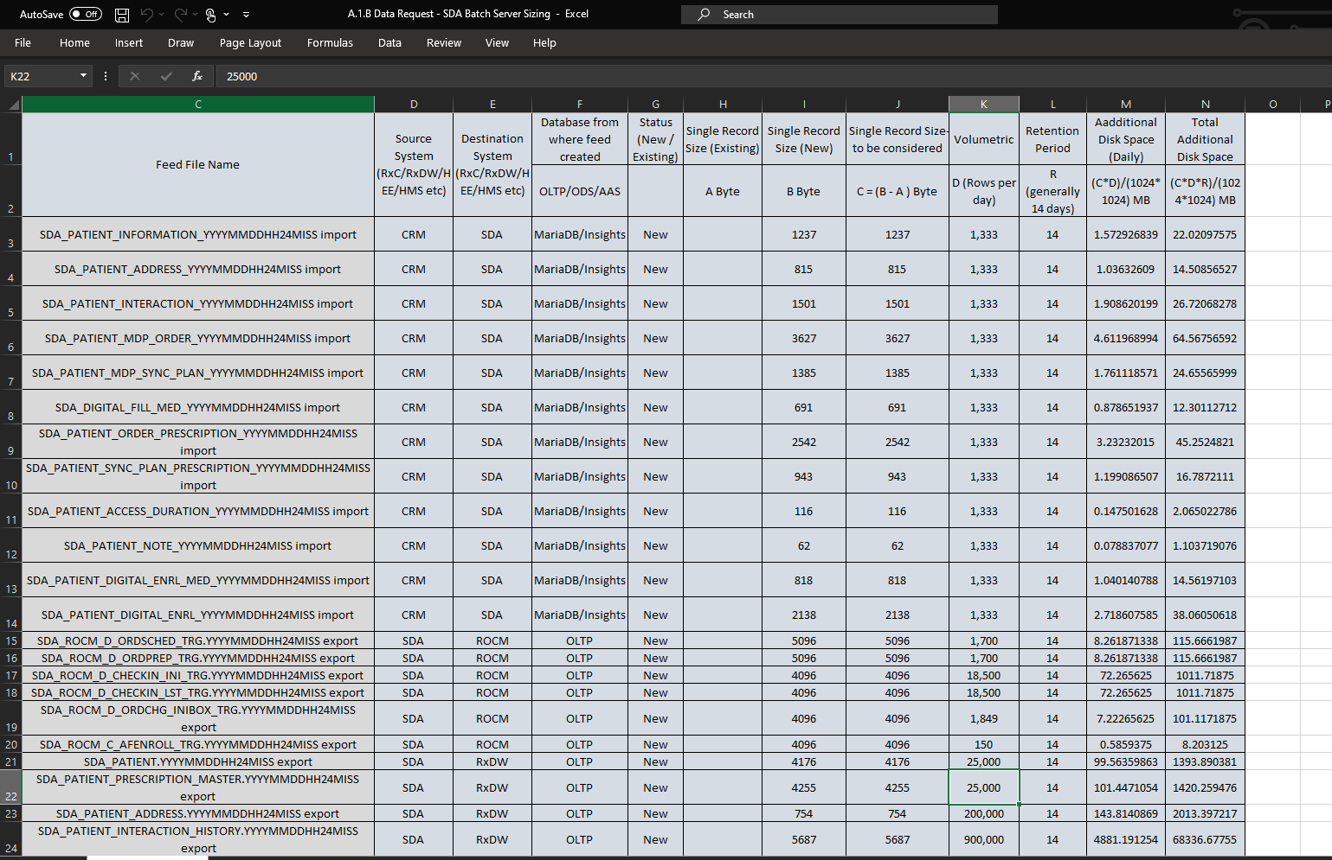Attribute B

List 3: Screenshot showing SimpleDose Application Batch Server Sizing

IA reviewed the entire rows and columns within the data sizing log. IA observed that each category of data imputation for SimpleDose is subcategorized into separate “Table Names” as seen in Row A1 in List 1 above. The total file size for each subcategory of data (Table Name) is highlighted in Row O and likewise a year to year growth for SimpleDose per 5% growth yield is estimated to reveal how much space will potentially be need by SimpleDose from 2021 through 2024.

Upon IA’s review of the Batch server sizing and a follow up walkthrough meeting with the application Development team, Padmalatha Ajit, Senior Manager, Application Development; noted that testing to support increased data needs for SimpleDose was carried out Prior to Phase 1 release. The current data storage provided for SimpleDose is sufficient enough to support Patient Pharmacy data volume and has been scaled up to include additional disk space which is estimate to last 2 to 3 years efficiently.

A.1.B

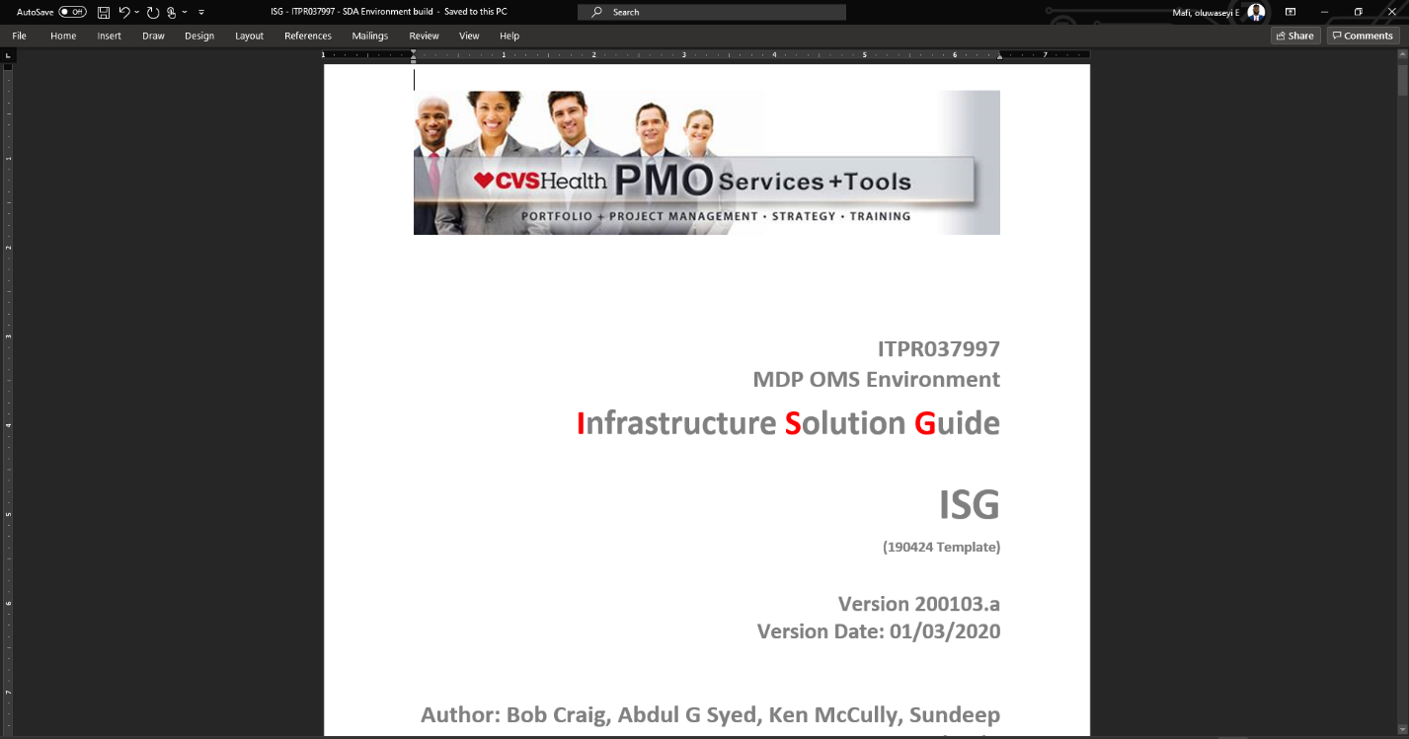

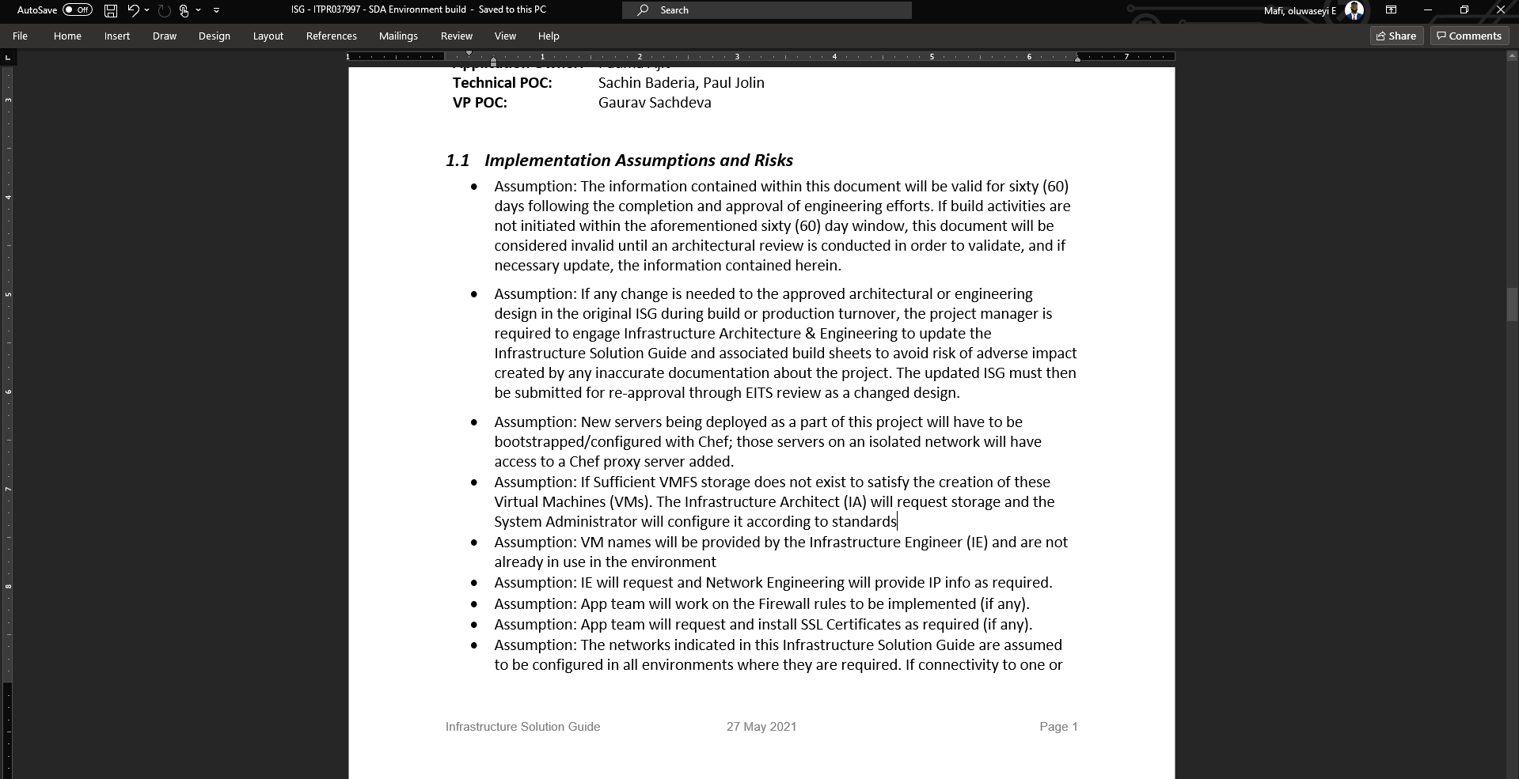

List 4: Screenshot showing SimpleDose Infrastructure Solution Guide ISG

IA reviewed the SimpleDose Infrastructure Solution Guide ISG and noted that if there is insufficient storage available during testing of storage requirements for Patient Pharmacy Data volume, the Infrastructure Architect (IA) will request for additional storage and the system administrator will configure according to Standards.

A.1.B